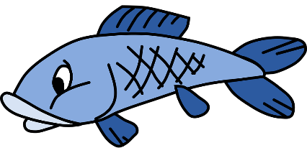

[Event Description Here. Ex: Enjoy Storytime with Mrs. Smith!

Make your own frog puppet !]

*For more info, contact us at:*

*[YOUR CONTACT HERE]*

*July is Lakes Appreciation Month! Join us for to kickoff our* ***Libraries Love Lakes*** *event!*

**When: July X, 2020, X p.m.**

**Where: Your Location Here**

Celebrate Lakes Appreciation Month at the Library!